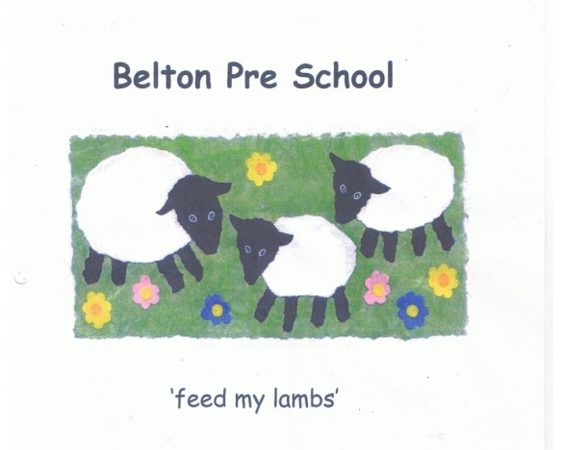

Early Years Foundation Stage

Promoting Positive Behaviour

At Belton Pre-school we believe in providing a secure and supportive environment in which children are helped to interact with one another positively, undertaking shared experiences while being sensitive to the needs and feelings of others. We believe that children and adults flourish best in an ordered environment in which everyone knows what is expected of them and children are free to develop without fear of being hurt or hindered by anyone else.

We will ensure that:

- All adults in the setting will have the necessary skills to advise other staff on behaviour issues and to access expert advice if necessary

- All adults will be positive role models for children with regard to friendliness, care and courtesy and endorse desirable behaviour such as kindness and willingness to share.

- The rules and boundaries of the setting are applied consistently, so that children have the security of knowing what is expected of them and are encouraged to behave positively

- We will make it clear that behaviour such as bullying, corporal or physical punishment in any form is not acceptable

- Rules of the setting will be discussed and agreed with both children and adults and explained to all newcomers

- The staff never threaten any punishment which could adversely affect a child's well-being or use corporal punishment and we will take all reasonable steps to ensure that corporal punishment is not given by any person who cares for or is in regular contact with a child as detailed in the DfE guidelines ‘Use of reasonable force in Schools’, or by any person living or working in the premises where care is provided

- The children will not be singled out or humiliated in any way at the setting or be sent out of the room by themselves

- Adults in the setting will make themselves aware of, and respect, a range of culture expectations regarding interactions between people.

- Adults will not shout, or raise their voices in a threatening way

- We keep a record of any occasion where physical intervention is used, and parents and or carers will be informed on the same day, or as soon as reasonably practicable

- In any case where a child’s behaviour is unacceptable, it will always be made clear to the child or children in question that it is the behaviour and not the child that is unwelcome

- When a child’s behaviour becomes unacceptable adults will support the child to identify their behaviour issues and work together to develop strategies that will support the child to develop behaviour that is acceptable

- In cases of serious behavioural problems, such as racial or other abuse, the unacceptability of the behaviour and attitudes will be made clear immediately, but by means of explanations rather than personal blame

- Staff have an understanding of the developmental stages of behaviours and any behavioural issues will be handled in a developmentally appropriate way, respecting individual children’s level of understanding and maturity

- Parents and staff will work together to encourage acceptable and consistent behaviour, parents will be made aware of the rules and boundaries of the setting and encouraged to support their children’s understanding of this

- Parents will be invited to share any concerns they have over their child’s behaviour and work with the setting to ensure a consistent approach can be agreed

- Recurring unacceptable behaviour will be addressed in partnership with the child’s parents

- We organise our environment to enable children to develop independence, and help children learn to negotiate with others and solve problems

Sandra Newbon has responsibility for the effective management of Promoting Positive Behaviour in our setting.

