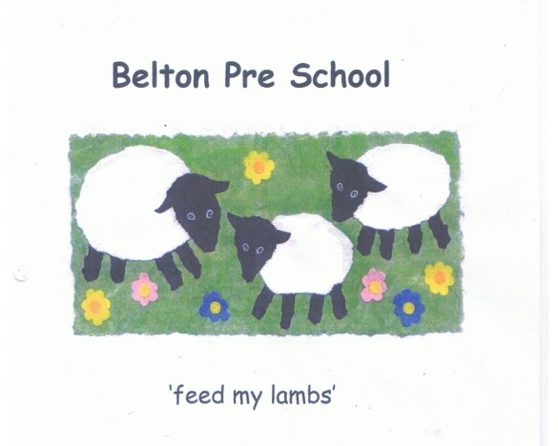Early Years Foundation Stage

Sick Child’s Policy

We promote the good health of children attending the setting. When a child becomes ill the setting will contact their parents and or carer at the earliest opportunity. This policy is to be read in conjunction with Managing Medicines Policy

We will:

- Inform Ofsted and the Health Protection Agency of notifiable diseases
in line with national requirements

- For the sake of all of the our children any child who is ill or recovering from an
infection or illness should not attend the setting until they are completely
recovered

- Work in partnership with other professionals and or agencies regarding to support any child with specific health issues to ensure they are fully included in all aspects of our provision

- If appropriate let other parents know about any infectious diseases at the setting, and ensure confidentiality issues are adhered to

- Discuss with parents the procedure to be followed in response to a child who is infectious to prevent the spread of infection, and take appropriate action if a child becomes ill

- If a child is unwell on arrival at the setting the needs of the child will be paramount in assessing the child’s wellbeing to remain at the setting

The procedure to be followed should a child become ill:

- Identify symptoms and take temperature

- Phone the parent and or carer if sickness starts while the child is at the setting

- Take care of the child in a quiet room, preferably by the child’s key person

- If the child has a high temperature try to reduce it by removing some of their clothing and sponging with tepid water until the parent or carer arrives

- To control cross infection, the following incubation periods should be adhered too:

Children should not attend the setting if they are suffering from any of the following illnesses. Please keep the child at home for the recommended number of days:

COMMUNICABLE DISEASES AND RECOVERY TIMESCALES

CHICKEN POX | Until blisters are all crusted, or skin has healed. A minimum of 5 days from onset of rash
CONJUNCTIVITIS | Until infection has cleared or prescribed antibiotic drops have been administered for a minimum of 24 hours
DIARRHOEA | For 48 hours after symptoms have cleared
GERMAN  MEASLES-RUBELLA | Minimum of 5 days after rash appears
HAND, FOOT AND  MOUTH | Whilst the child is unwell
HEAD LICE | When treatment has been carried out successfully
IMPETIGO | 48 hours after starting antibiotic treatment
MEASLES | For 5 days after onset of rash
MUMPS | For 5 days (after onset of swollen glands)
RINGWORM | When treatment has commenced
ROTAVIRUS | For 48 hours from last episode of diarrhoea or vomiting
SCABIES | Child can return after first treatment has been completed
SCARLET FEVER | For a minimum of 5 days (once antibiotics commenced)
THREADWORM | When treatment has commenced
VOMITTING | For 48 hours after symptoms have cleared
WHOOPING COUGH | 5 days from start of antibiotic treatment or 21 days from  onset of illness if no antibiotic treatment prescribed by GP
ANITBOTICS | Children on antibiotics must be excluded from Nursery for the  first 24 hours
A TEMPERATURE | Until temperature is normal for 24 hours or on the advice of a doctor

Please note this list is not exhaustive and the advice is taken from the Guidance for Schools & Nurseries from the Health Prevention Agency. We also refer to the NHS Direct Healthcare Guide. Please seek medical advice if you are unsure or concerned.

