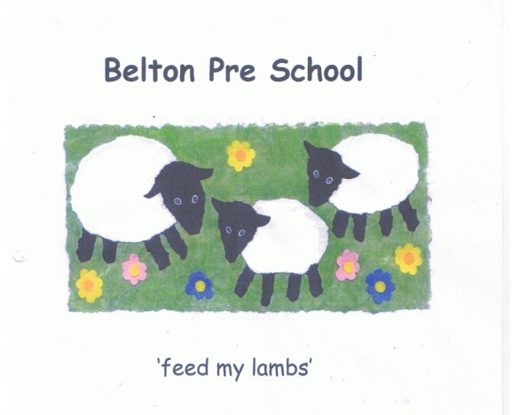

Early Years Foundation Stage Model Policies

Health and Safety Policy

We will implement our health and safety policy, and procedures, which cover identifying, reporting and dealing with accidents, hazards and faulty equipment we have an identified member of staff responsible for health and safety who ensures that the setting complies with legislation, however, all staff have a responsibility to be vigilant with regard to act upon any issues with regard to health and safety.

We will ensure that:

- Our premises, including outdoor spaces, are fit for purpose. Spaces, furniture, equipment and toys, will be safe for children to use and checked daily prior to children’s arrivals

- Our premises will be secure and the outdoor area is securely fenced and checked for safety
- We keep premises and equipment clean, and are aware of, and comply with, requirements of health and safety legislation, including hygiene requirements
- There is an adequate number of toilets and hand basins available ,usually one toilet and one hand basin for every ten children over the age of two, and provide separate toilet facilities for adults

- There are suitable hygienic changing facilities for changing any children who are in nappies

- We carry public liability insurance

- We have a clear and well-understood policy, and procedures, for assessing any risks to children’s safety and review risk assessments regularly
- Our premises will be cleaned regularly, adequately ventilated, heated between 18-24 degrees Celsius, well lit and providing children with access to natural daylight

- The premises and equipment will be organised to meet the needs of the children and we will inform Ofsted of any significant changes or events relating to the premises

- Wherever possible we use non-toxic environmentally friendly cleaning chemicals that are stored out of reach of children. Protective aprons, gloves and other equipment are used wherever necessary and all waste materials are disposed of hygienically

- Electrical equipment is regularly checked, PAT tested and used in a safe manner

- Sockets are out of the reach of the children, have safety covers and are not overloaded. All cables and leads are taped down and all appliances are kept indoors away from water

- The legal requirements regarding space from the EYFS are met

- There is a designated area for children who wish to relax, or sleep and sleeping children will be frequently checked

- The premises will be available for sole use of the setting during hours of operation

- Staff will be made aware of security issues and how this impacts on their safety and the safety of others

- Staff will act as good role models to the children at all times by respecting and caring for the resources be vigilant and proactive in contributing to the daily maintenance of the setting

- Training, instruction and supervision is constantly being undertaken at all levels to ensure the safety of everyone at the setting

- All resources will meet the relevant legal safety standards and be regularly checked to ensure safety

- Ratios of staff to children will be maintained for all areas at all times and staff have a responsibility, under the Health and Safety at Work Act, for their own health and safety and others

- Children are made aware of health and safety issues through discussion, planned activities and our daily routines, encourage the children to learn about personal hygiene

- Staff and children are alerted to the dangers of poisonous plants, herbicides and pesticides

Risk Assessment:

- We will have a clear and well-understood policy, and procedures, for assessing any risks to children’s safety, and review risk assessments regularly

- We will determine where it is helpful to make some written risk assessments in relation to specific issues, to inform staff practice, and to demonstrate how they are managing risks if asked by parents and or carers or inspectors.

- Risk assessments will identify aspects of the environment that need to be checked on a regular basis, when and by whom those aspects will be checked, and how the risk will be removed or minimised

