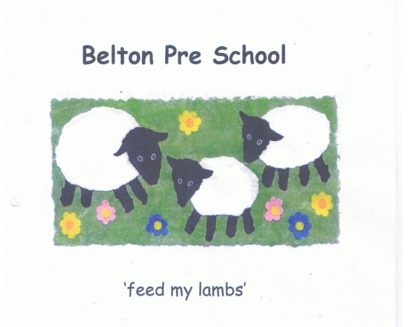
Early Years Foundation Stage

Data Protection and Confidentiality Policy

Our work brings us into contact with confidential information about the children and their families in our care. To ensure that we respect confidentiality and privacy we will ensure that:

- Parents will have access to information of their own children, provided that no relevant exemptions apply to their disclosure under the DPA 1998, but will not
have access to information about any other child

- Issues to do with employment of staff whether paid or unpaid will remain
confidential to the people directly involved in the decision making process, including the Committee who are the governing body for the Pre-school.

- Staff will not discuss private matters about any child in the Provision with anyone other than their parent

- Provide a suitable secure area for the storage of confidential information

- Ensure information and records about staff and children are only accessible to those who have a right or professional need to see them will do so
.
- We will ensure that the office is available for staff to talk to parents and or carers confidentially when required.

- Ensure records relating to individual children are retained in safe storage for 7 years after the children have left the Provision

Any parent bringing a child into the setting or working as a helper will be in close contact with other people’s children and may learn things about them that they would not otherwise know. Children may tell others things about themselves and their families or they may observe things that allow them to draw conclusions. This information is personal and private and must be treated with respect and in total confidence, sharing only with identified people in the setting.

