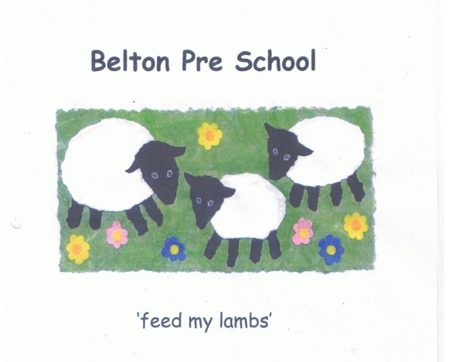

Early Years Foundation Stage

Policy for Belton Pre-School Staff Professional Development,
Training and Teaching

- To develop a system to raise the quality of teaching across the pre-school.
- To engage and enthuse staff in their own professional development.
- To build a programme of new, interesting and ambitious training initiatives.
- To observe and evaluate staff practice more accurately and effectively in order to raise the overall quality of teaching.
- To offer meaningful, fair, informative and well-communicated appraisals.
- To empower individuals who work in the pre-school and ensure that all staff strive for continuous improvement in the setting and their own practice
- Above all else, to deliver a high standard of care and EY education to all children who attend the pre-school
How we will go about doing this:

- The manager will share planning and feedback with staff on a daily basis to ensure all involved in the provision of care are aware of any developments or concerns about individual children or relevant issues.
- The manager will supervise staff effectively by conducting regular spontaneous as well as planned observations of the staff. Peer on peer observations should also be used. Feedback will be delivered promptly and documented where possible. A written record of the observation should signed by the observed and observer to record the discussion. All relevant material should to be used to inform staff appraisals.
- The manager will conduct annual appraisals for staff and review targets and all aspects of these six months later. The same process will be undertaken by members of the committee for the manager's appraisal.
- Appraisals and ongoing communication between the manager and staff will identify individual training needs and be used to tailor a professional development plan for each practitioner
- The manager and staff will participate in any training or conferences offered by the local authority or any other relevant body
- Staff will take part in any additional training organised or offered by the setting
- Any training that has taken place in addition to mandatory training will be shared in a formal way amongst all staff and be used by all to improve teaching and care across the setting
- Staff will ensure that training they undertake is used to positive effect in the setting and supports better outcomes for the children's Early years development
- Staff will be well-informed about documentation and policies that relate to Early years education.
- Staff will participate in visits to other settings and identify new ideas or methods of teaching that would benefit the pre-school. They should work in conjunction with the rest of the staff to introduce these where appropriate.
- The Committee and Staff will appoint a Continuous Improvement Lead who will work to promote new ideas, and genera improvement in teaching and practice across the pre-school.

Staff to sign below to acknowledge they have read and understand this policy:

……………………………………………………………… Dated: …………………………… Sandra Newbon

……………………………………………………………… Dated: …………………………… Jenny James

……………………………………………………………… Dated: …………………………… Rachel Eyre

……………………………………………………………… Dated: …………………………… Jayne Howard

……………………………………………………………… Dated: …………………………… Dawn Griggs

……………………………………………………………… Dated: …………………………… Louise De’Ath

……………………………………………………………… Dated: …………………………… Lydia Harding

