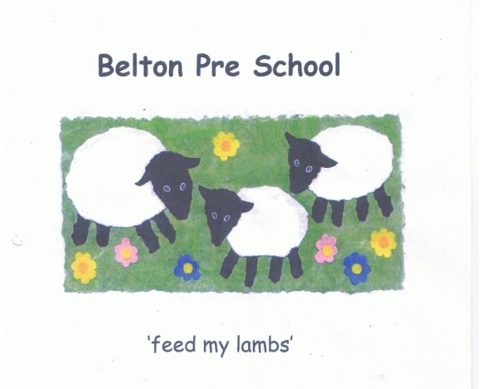

Early Years Foundation Stage

ICT and E-Safety Policy

At Belton Pre-school we will take all necessary steps to keep children safe and that includes creating a safe ICT learning environment. We recognise that the Internet is a wonderful resource for supporting children’s development and learning and the setting will have procedures in place to safeguard children. One of the EYFS early learning goals is ‘Technology’ and recognises that children use a range of technology in their homes and in the setting.
Technology:

- We will encourage our children to use technology as part of their every day development and learning taking every precaution to keep or children and staff safe

- We will endeavour to create age appropriate opportunities for children to experience and use of everyday technology

- We will also look to promote the use of technology when out in the environment encouraging children to press buttons in lifts and at pelican crossings.

Computer technology:

- We will help children to learn to understand the main features of a computer or other forms of technology. Encourage children to use a mouse and different programmes to broaden their experience

- We will offer appropriate support to young children, when they are using the computer

- We will endeavour to provide appropriate recourses and opportunities for the age and stage of development and learning of the children

Internet:

- We will work with parents to ensure they are aware of our internet use and gain consent for their children to use the internet while at the setting and ensure that they follow the rules for safe internet use at all times

- Staff will attend appropriate training to support children in this area and will supervise children’s activities on the Internet

- Staff within the setting will be required to take necessary precautions to protect children in their care from harm whilst using the webcam and Internet

- We will use filtering software to block inappropriate sites

- Personal details will not be shared over the internet

- Arrangements to meet others will not be made via the internet

- Any inappropriate materials sent to the computer must be reported to the person in charge

- Computer files may be checked and the internet sites visited may be monitored

E-mail:

- E-mail correspondence will be directed only to people who have been approved and messages sent will be polite and responsible

- We will only transfer child level information through the LA secure transfer process

Social networking

Social networking has now become an integral part of everyday life. However, we are also well aware that these sites can become a negative forum for complaining or gossiping and care must be taken not to breach our confidentiality policy or offend anyone when using these sites. Staff members clear guidelines as to what we expect of our staff when accessing these sites.

We will not:
- Post any information regarding children, their parents or families or other staff at the setting

- Use photographs of children from the setting without permission

- Use photographs of members of staff without their consent

- Post remarks which breach confidentiality or are deemed to be of a detrimental nature to the setting or other employees

We will ensure:

- We maintain professionalism whilst using social networking sites

- That any employee, who becomes aware of social networking activity that would be deemed distasteful or not appropriate, should make their Head teacher or Setting manager aware of the activity

- That personal blogs, by staff, have clear disclaimers that state that the views expressed by the author on the blog are the author’s views alone and so do not represent the views of the setting and make clear that they are speaking for themselves and not on behalf of the setting

- That information published on blogs should comply with the confidentiality and disclosure of our settings data policies

- Any disrespectful comments to the above may be seen as libellous
- Any breach of confidentiality will result in disciplinary action and may result in termination of staff’s contract

- That at all times, in or out of working hours, staff are ambassadors for our setting

- That we respect copyright laws, and reference or cite sources appropriately

- That Nursery Logos and trademarks will not be used without approval

