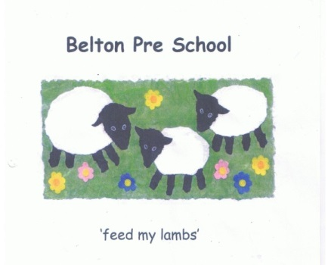Early Years Foundation Stage

Staffing and Employment Policy

The setting is committed to recruiting, appointing and employing staff who have the
appropriate qualifications, training and skills for looking after children in our care.

Procedures for appointing new staff will be followed rigorously to ensure fairness for everyone.

We will ensure that:

- We advertise vacancies through a number of avenues

- During interviews candidates will be questioned about their suitability for the post against the criteria set out in the job description
.
- All candidates will be asked the same questions

- No less than two people will be involved in the recruitment and interviewing process and awareness of the ‘safer recruitment’ training programme

- References will be taken up in all instances along with a full employment history

- Employment will be dependent upon obtaining clearance from the Disclosure and Baring Service and validation of qualifications all other relevant checks will be undertaken such as medical suitability

- Any member of staff awaiting the clearance from the Disclosure and Baring Service will be supervised in the setting at all times

- All staff have a contract of employment and a job description appropriate to their role

- We notify Ofsted of any changes outlined in the legal requirements of the EYFS

- The provision will agree a probationary period for new employees, during which there will be regular opportunities for feedback and discussion prior to the position being made permanent
- All staff are given information and copies of the provisions policies and procedures

- All staff receive induction training to help them understand their roles and responsibilities

- Induction training will include information about emergency evacuation procedures, safeguarding, child protection, the provider’s equality policy, and health and safety issues.

- Induction process will make staff aware of their rights on employment matters

- At all times we endeavour to act as a good employer by adopting policies, procedures and working practices that meet all relevant legal requirements and where ever possible offer a family friendly working environment

- Staffing arrangements will meet the needs of all children and ensure their safety and meet the legal requirements of the EYFS

- All children are adequately supervised and staff are deployed to ensure children’s needs are met
- We provide an area for staff to take breaks away from areas being used by the children

- We inform parents and or carers about staff deployment, and, when relevant and practical, aim to involve them in these decisions
- ‘Children will always be within sight or hearing of staff
- Regular staff meetings will provide the opportunities for staff to share their achievements, knowledge, concerns and identify areas for development within the provision

- Staff meetings also offer the opportunity for everyone to undertake
planning activities to support each child‘s development within the EYFS
framework

- Practitioners are never under the influence of alcohol or any other substance which may affect their ability to care for children. Any employee found under the influence of alcohol or drugs will be dealt with under the setting’s disciplinary procedures

- Smoking by staff will not be permitted anywhere in the setting or in the vicinity of the setting

- Practitioners on prescribed medication only work directly with children if medical advice confirms that the medication is unlikely to impair that staff member’s ability to look after children properly

- Staff medication on the premises will be securely stored, and out of reach of children, at all times

- All staff qualifications, experience and ratios of staff to children meet the legal requirements of the EYFS

- Practitioners standing in during staff absence meet the legal requirements of the EYFS and have the necessary qualifications and experience to do so

- We put appropriate arrangements in place for the supervision of all staff

- Regular staff appraisals are carried out to identify any training needs, and secure opportunities for continued professional development for staff

- We support our staff to improve their qualification levels wherever possible

- At least one person who has a current paediatric first aid certificate is on the premises at all times when children are present, and must accompany children on outings

- First aid training is Local Authority approved and relevant for workers caring for young children

- Staff have sufficient understanding and use of English to ensure the well-being of children in their care and are able to keep records in English, to liaise with other agencies in English, to summon emergency help, and to understand instructions such as those for the safety of medicines or food hygiene

