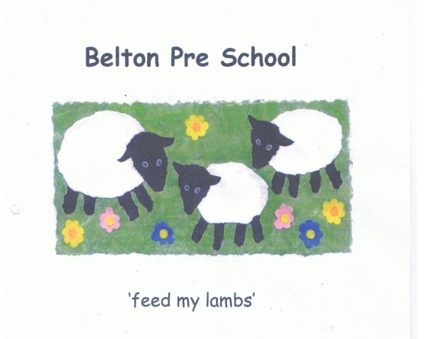

Early Years Foundation Stage

Nappy Changing Policy

No child is excluded from participating in our setting who may, for any reason, not yet be toilet trained and who may still be wearing nappies or equivalent.

- We work with parents towards toilet training, unless there are medical or other developmental reasons why this may not be appropriate at the time.

- We make necessary adjustments to our bathroom provision and hygiene practice in order to accommodate children who are not yet toilet trained.

- We see toilet training as a self-care skill that children have the opportunity to learn with the full support and non-judgemental concern of adults.

EYFS Key Themes and Commitments
A Unique Child | Positive Relationships | Enabling Environments | Learning and Development
1.2 Inclusive practice  1.4 Health and wellbeing | 2.2 Parents as partners  2.4 Key person | 3.2 Supporting every child

Procedures

- Changing areas are warm and there are safe areas to lay young children if they need to have their bottoms cleaned.

- Each young child has their own bag to hand with their nappies or pull-ups and changing wipes.

- Disposable gloves and aprons are put on before changing starts and areas are prepared. Paper towel is put down on the changing mat freshly for each child; you should wear a new set of gloves for soiled nappies and one new glove for wet nappies.

- All staff are familiar with hygiene procedures and carry these out when changing nappies.

- In addition, Preschool Assistants ensure that nappy changing is relaxed and a time to promote independence in young children.

- Using wipes, clean the child from the front to the back.

- Young children are encouraged to take an interest in using the toilet, they may just want to sit on it and talk to a friend who is also using the toilet / potty.
- They should be encouraged to wash their hands and soap and hand towels to hand. They should be allowed time for play as they explore the water and soap.

- Antibacterial hand wash or soap should not be used for young children.

- Pre-school Assistants are gentle when changing, they avoid pulling faces and making negative comments about 'nappy contents’.

- Pre-school Assistants do not make inappropriate comments about young children’s genitals when changing their nappies.

- Older children access the toilet when they have the need to and are encouraged to be independent.

- Nappies and ‘pull ups’ are disposed of hygienically. Any soil (faeces) in nappies or pull ups is flushed down the toilet and the nappy or pull up bagged and put in the bin. Cloth nappies, trainer pants and ordinary pants that have been wet or soiled are bagged for the child to take home or if they are beyond saving we will dispose of them and a replacement pair will be offered if required.

- The nappy changing mat should be cleaned with anti-bacterial spray and paper towel dry the changing mat. Then wash and dry your hands.

- NB if young children are left in wet or soiled nappies / ‘pull ups’ in the setting, this may constitute neglect and will be a disciplinary matter. Settings have a duty of care towards children’s personal needs.

